I am sending u step by step document
Step 1-
This is my Aspx and C# code which is calling the Stored procedure named “InsertStudentName”
ASPX Code

<%@ Page Language="C#" AutoEventWireup="true" CodeFile="Checkprocedure.aspx.cs" Inherits="ERM_Checkprocedure" %>

<!DOCTYPE html PUBLIC "-//W3C//DTD XHTML 1.0 Transitional//EN" "http://www.w3.org/TR/xhtml1/DTD/xhtml1-transitional.dtd">

<html xmlns="http://www.w3.org/1999/xhtml">
<head runat="server">
<title></title>
</head>
<body>
<form id="form1" runat="server">
<div>
<asp:TextBox ID="TextBox1" runat="server"></asp:TextBox>
<asp:Button ID="Button1" runat="server" Text="Button" onclick="Button1_Click" />
</div>
</form>
</body>
</html>

C# Code

using System;
using System.Collections;
using System.Configuration;
using System.Data;
using System.Linq;
using System.Web;
using System.Web.Security;
using System.Web.UI;
using System.Web.UI.HtmlControls;
using System.Web.UI.WebControls;
using System.Web.UI.WebControls.WebParts;
using System.Xml.Linq;
using MySql.Data.MySqlClient;
using System.Globalization;

public partial class ERM_Checkprocedure : System.Web.UI.Page
{
MySqlConnection connection = new MySqlConnection(ConfigurationManager.ConnectionStrings["MultiErmConnectionString"].ConnectionString);

protected void Page_Load(object sender, EventArgs e)
{

}
protected void Button1_Click(object sender, EventArgs e)
{
try
{
connection.Open();
MySqlCommand cmd1 = new MySqlCommand("InsertStudentName", connection);
cmd1.CommandType = CommandType.StoredProcedure;
cmd1.Parameters.Add(new MySqlParameter("StudentName", TextBox1.Text));
cmd1.ExecuteNonQuery();

}
catch (Exception ex)
{
throw ex;
}
finally
{
connection.Close();
}
}
}

Stored Procedure

DELIMITER $$
CREATE PROCEDURE `InsertStudentName`( in Studentname varchar(100))
begin
insert into student(student_name)values(Studentname);
end

Connection String
<add name="MultiErmConnectionString" connectionString="server=208.83.233.2;user id=asiancorp_1;password=host@123;database=asiancorp_1;Min Pool Size=5; Max Pool Size=10000;Connect Timeout=10000;" providerName="MySql.Data.MySqlClient" />

Step-2
Now when I am executing this code in local host ,the stored procedure is inserting data well in student table!


It adding student name successfully!
Step-2(online)
Link- http://asiancorp.net/ERM/Checkprocedure.aspx
Now i created the stored procedure in phpmyadmin!It has created successfully but when I saving
Student name into student table then it is giving error

“Procedure or function '`InsertStudentName`' cannot be found in database '`asiancorp_1`'.“

But stored Procedure and table “student” is in the database '`asiancorp_1.i am showing this in screenshot

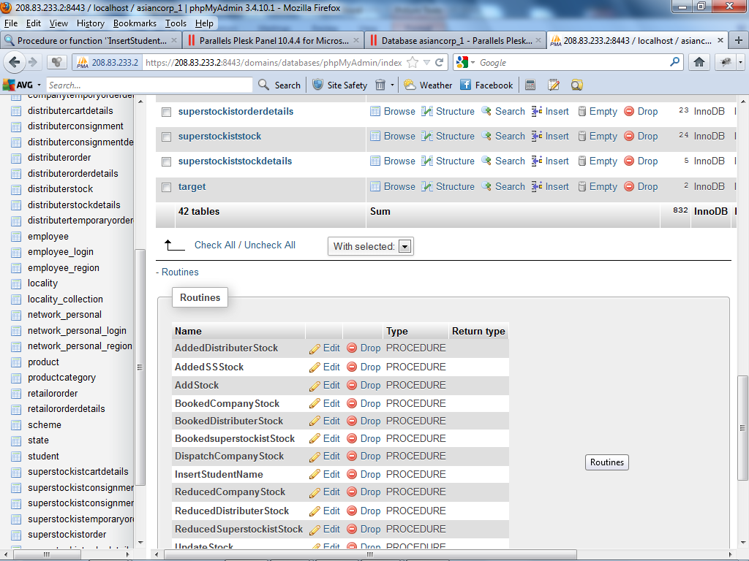

Online link- http://asiancorp.net/ERM/Checkprocedure.aspx